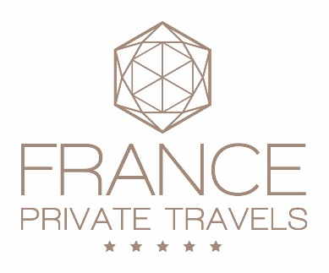
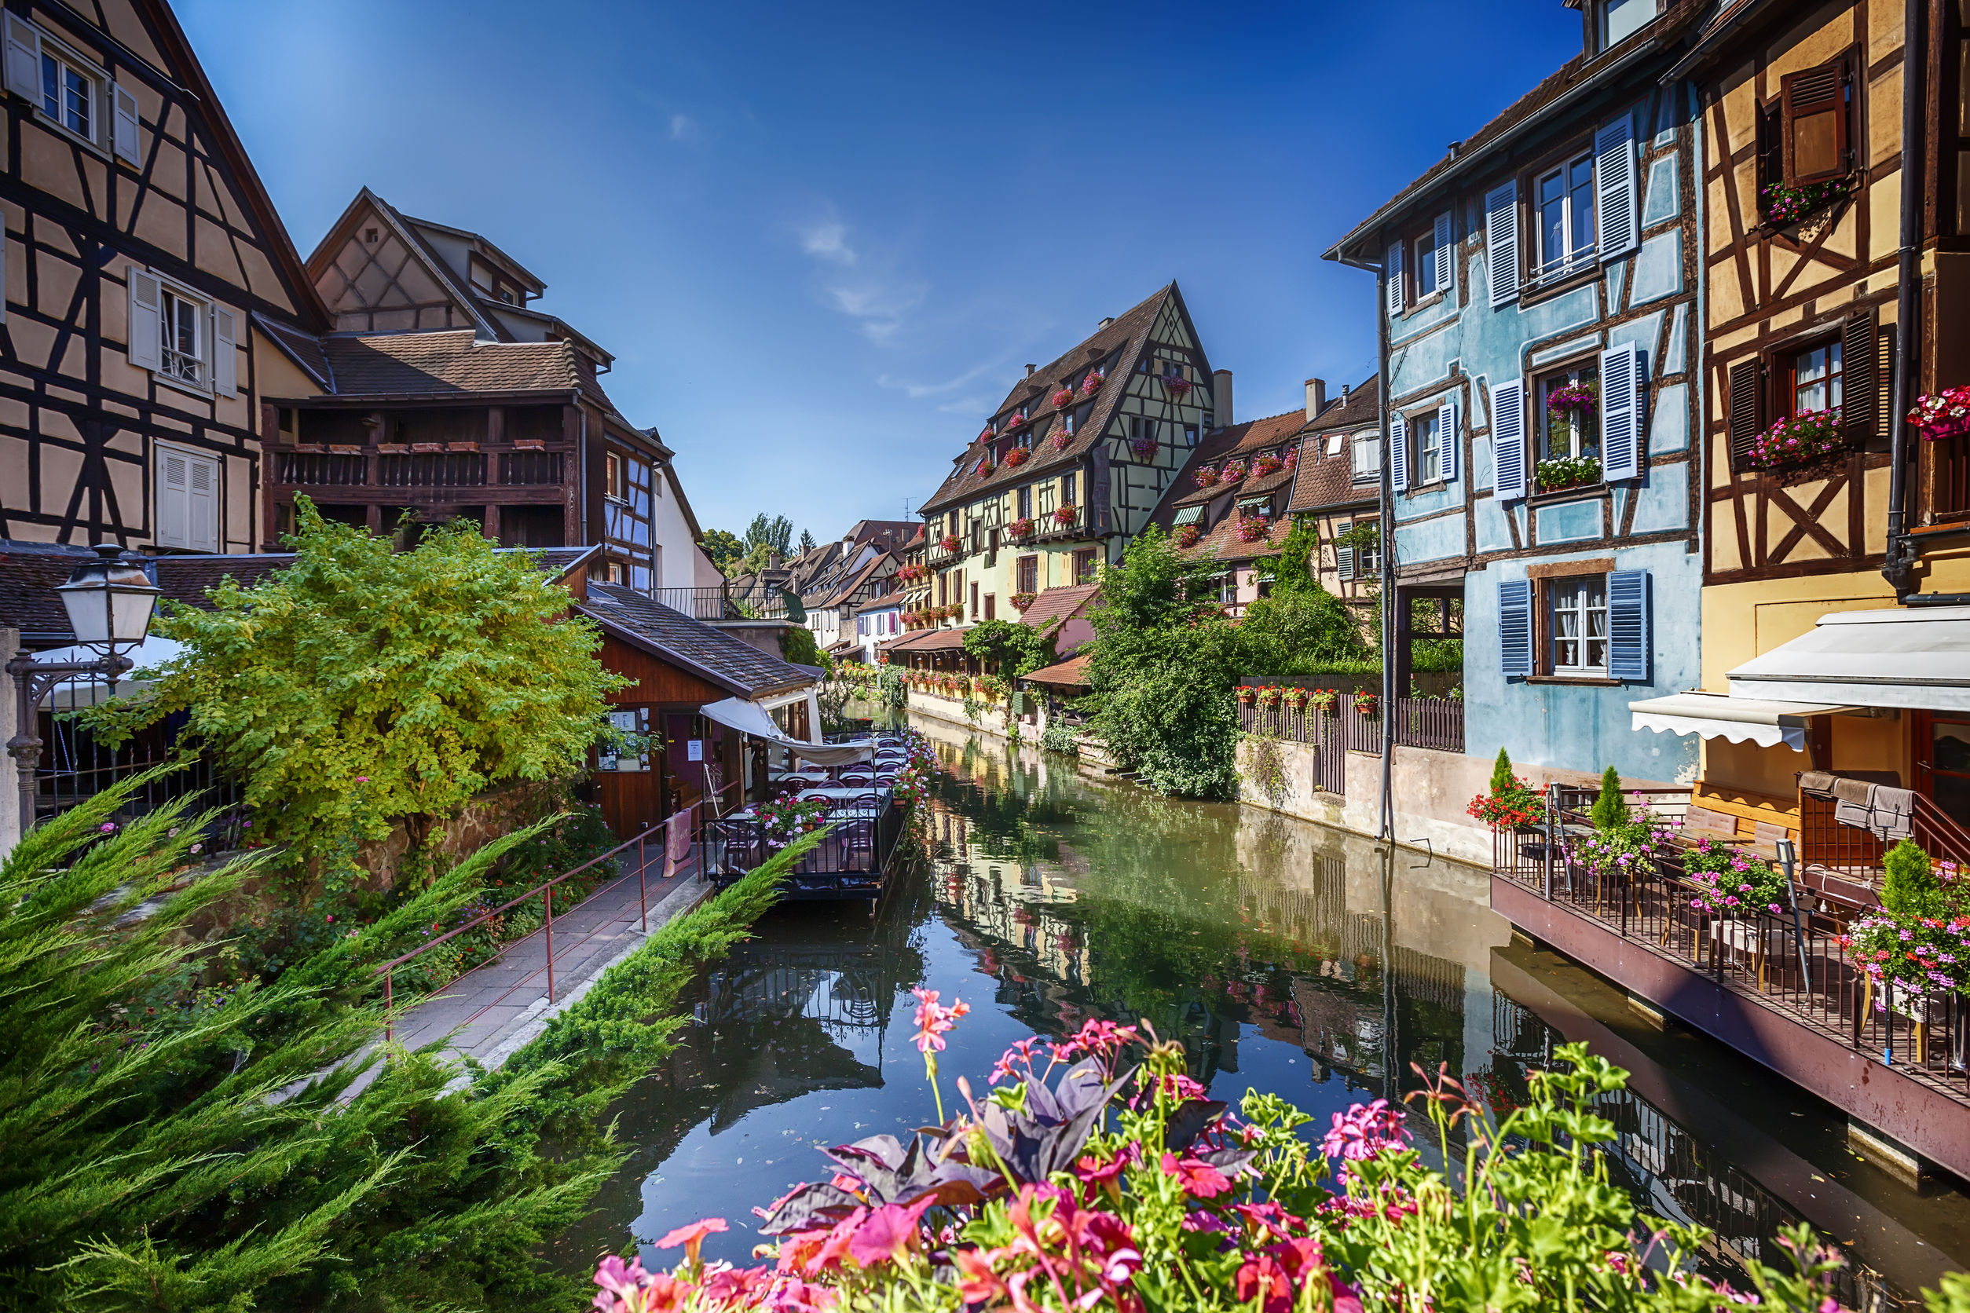

“Life is magnific in Alsace!”

5 days/4 nights (from 1 to 6 persons)
Price based on 2 persons
Departure from: Strasbourg station or airport
Return on: Strasbourg station or airport

Highlights of the tour:
- A privileged introduction to Alsace with private and exclusive tours and visits together with local experts
- Visits of some of the pearls of Alsace: Strasbourg, Colmar, Obernai, Riquewihr, Mittelbergheim…
- Discovery of the Alsace Wine Route and private tasting of great wines

Explore your tour:
Day 1:
Arrival at Strasbourg station or airport. Private pick-up and drop-off at your hotel in Strasbourg, the Bouclier d’Or 4*. With its 22 unique luxury rooms and suites, a spa and a bar, the beautiful boutique hotel Le Bouclier d’Or lies in the heart of the Petite France, the historical center of Strasbourg. This tastefully renovated Bourgeois-style Mansion marries original architecture with the latest technologies and environmentally friendly features.
Other alternatives are possible, such as for instance the Sofitel Strasbourg Grande Île 5*, the Régent Petite France 5*, or the Cour du Corbeau 4*.
Diner suggested at the famous winstub “Chez Yvonne”, offering a refined local cuisine.

Day 2:
The capital of both Europe and Alsace, Strasbourg has a worldwide renowned historical heritage: the Grande Ile area is listed a UNESCO World Heritage Site.
In the morning, your guide will pick you up from your hotel for a private guided walking tour. You will visit the ‘Petite France’ area, the most picturesque district of Old Strasbourg, the Cathedral which has
just celebrated the 1000th anniversary of its foundations, the House Kammerzell…You will also have the opportunity to taste Mireille Oster’s famous gingerbread at her boutique.
After the walking tour, you will enjoy having lunch at a winstub, a typical Alsatian tavern known for its friendly atmosphere serving local specialties such as choucroute (sauerkraut, with pork or with fish), baeckoeffe, spaetzle, foie gras, kougelhopf, flammekueche, gingerbread…
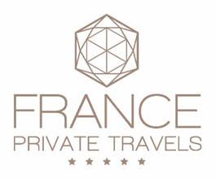

In the afternoon, you will tour on the Ill river on a boat, which is a great way to discover the half-timbered houses of the ‘Petite France’, the Imperial district, and the European Institutions. You will then have free time to visit some of the museums of Strasbourg such as for instance the Palais Rohan, the Alsatian Museum, the Historical Museum, the Oeuvre Notre Dame Museum, or the Museum of Modern and Contemporary Arts. You may also wish to visit the historical cellar at the Strasbourg Hospital, which is over 600 years old and which still holds wine from 1472!
If you prefer, why not take advantage of the numerous exclusive shopping possibilities in Strasbourg: Louis Vuitton, Hermès, Lalique, Swarovski, Pierre Hermé, Galeries Lafayette, Hugo Boss, Cartier, Baccarat, Pavillon Christofle…Your guide will be happy to assist you finding the right places for you.
Free time for dinner.
Accommodation at Le Bouclier d’Or 4*or at the Sofitel Strasbourg Grande Île 5*, the Régent Petite France 5*, or the Cour du Corbeau 4*.

Day 3:
This morning, your private guide will pick you up in a comfortable car from your hotel in Strasbourg and drive you to the Alsace Wine Route for the rest of the day where you will marvel at the beauty and diversity of the landscape and will stroll through picturesque villages surrounded by vineyards where you can admire the traditional half-timbered houses and their balconies, overflowing with flowers.
You will start with the visit of Obernai, a charming medieval town and then continue with a visit of the renowned Spindler’s wood marquetry in Boersch, a famous symbol of arts & crafts in Alsace. Jean-Charles Spindler, the 3rd generation of this family of artists, will open the doors of his private little museum just for you.
In Mittelbergheim, a superb village with a characteristic Renaissance style architecture, ranked among the ‘Most Beautiful Villages of France’, you will do a wine-tasting at a reputed winery together with the owner who will guide you in his cellar dating from 17th century. You will taste the Zotzenberg Sylvaner Grand Cru, the only Sylvaner Grand Cru in the world!
You will have a nice lunch at a typical and authentic restaurant on the Wine Route.
Naturally, you will also visit Colmar, the Alsatian wine capital, where strolling is so enjoyable. You will discover the Little Venice area, and its historical and architectural heritage. You will also be able to visit the New Unterlinden Museum located in a former Dominican convent which hosts one of the most famous European art masterpieces from the Middle Ages, the Isenheim Altarpiece dating from 1512-1516.

Accommodation at Le Bouclier d’Or 4*or at the Sofitel Strasbourg Grande Île 5*, the Régent Petite France 5*, the Cour du Corbeau 4*, or alternatively on the Wine Route, for instance at the Maison des Têtes 5* in Colmar, the Hôtel du Parc & Spa 4* in Obernai or the Hostellerie des Châteaux & Spa 4* in Ottrott.

Day 4:
This morning, your private guide will drive you to the Haut-Koenigsbourg castle. The castle is one of the symbols of the Alsatian heritage and a witness to the course of European history. A private guided tour will allow you to become more familiar with the castle architecture, the Middle-Ages and the early 20th century restoration.

You will then have lunch at an authentic quality restaurant in Bergheim, a typical Alsatian village.
You will also visit Riquewihr ranked among the ‘Most Beautiful Villages of France’, and end the day with an exclusive visit at a winery together with the owner. You will taste some of the wines which have made the reputation of the Alsace vineyard. The combination of a rich soil and generations of winemaking skills have made Alsace one of the world’s premier wine regions. With 51 Grand Crus and seven types of grapes (Riesling, Gewurztraminer, Pinot Gris, Pinot Blanc, Pinot Noir, Sylvaner, Muscat), Alsatian wines are acclaimed the world over.
Accommodation at Le Bouclier d’Or 4*or at the Sofitel Strasbourg Grande Île 5*, the Régent Petite France 5*, the Cour du Corbeau 4*, or alternatively on the Wine Route, for instance at the Maison des Têtes 5* in Colmar, the Hôtel du Parc & Spa 4* in Obernai, or the Hostellerie des Châteaux & Spa 4* in Ottrott.

Day 5:
Your private driver will bring you to the Strasbourg station or to the airport.
End of our services

Add one or more options to this tour – ask it to your expert:
A culinary tour in Strasbourg: your passionate guide will bring you to carefully selected places where you will taste the finest specialties which have contributed to the gastronomic reputation of Alsace. You will taste for instance one of the best kougelhopfs in the region, a selection of Alsatian charcuteries & foie gras, exceptional cheese at a typical French fromagerie, the famous macarons, chocolates, and cakes from Pierre Hermé, a selection of French pastries accompanied by coffee and chocolates made by a renowned pastry chef…
Price: from € 80 per person

Cooking class at a farm-inn: 2 to 3 hour cooking class followed by lunch or dinner at a farm-inn located in the Vosges mountains. The restaurant can be fully privatized for you!
Price: from € 150 per person

Discovery flight in a hot-air balloon: a wonderful way to discover Alsace from the sky! Duration: 4 to 5 hours, including 1 to 2 hours for the flight. Flight is subject to good meteorological conditions, meaning calm wind and great visibility. For security and aerology reasons, the takeoffs occur at dawn or at dusk.
Price: from € 320 per person

This price includes:
- The transfers from Strasbourg station or airport to your hotel
- The expertise of a private guide in a comfortable minivan
- All visits mentioned in the program
- 2 wine tastings at quality wineries
- The entrance tickets to the Haut-Koenigsbourg castle
- 4 nights accommodation including breakfast at one of the hotels mentioned (price may vary depending on the hotel chosen and the period)

This price does not include:
- Lunches & dinners
- The options
- Insurances
- Personal expenses

Cancellation charges:
- More than 45 days before the beginning of the stay: 5% of total amount of the stay
- From 45 to 31 days before the beginning of the stay: 15% of total amount of the stay
- From 30 to 21 days before the beginning of the stay: 35% of total amount of the stay
- From 20 to 8 days before the beginning of the stay: 75% of total amount of the stay
- Less than 7 days before the beginning of the tour or no-show: 100% of total amount of the stay

